**Lesson Demo**

**Calculated Fields**

**Business Scenario:**

A retail company is planning to launch a new sales strategy. As you are a regional manager, you are asked to create a sales goal based on historical performances. The company wants to increase sales by 20% in all states where they have achieved a certain level of penetration—a minimum of 100 customers. For the remaining states where they have fewer than a hundred customers each, you must calculate the sales that would result if they had 100 customers in that state. Now, create a visualization in Tableau using a bullet chart. The chart should show the states, the number of customers, and the actual vs. sales goal.

* Which state has the lowest customer count, and what is the count?
* How many states have a customer count of at least 100? (**Note**: Place the distinct count of customer name field on filters)

**Overview:**

* Create a set to show states with 100 or more customers
* Create a calculated field to show the average sales per customer
* Create a calculated field to show sales goals
* Create a calculated field to show emerging and developing states
* Create a view using the bullet chart

The result should resemble the image given below:

**Detailed Instructions:**

1. Graphical user interface, text, application

   Description automatically generated From the home page, connect to the saved **Sample - Superstore** dataset
2. From **Dimensions**, locate and right-click **Customer Name**. To create a set, select **Create** and next click on **Set**

1. In the Create Set window, enter the name as **States with 100+ Customers**. Navigate to the **Condition** tab; Select **By field**. Apply condition as **Count(Customer Name) >= 100**. Click **OK**

1. To determine average sales by customer, create a calculated field. Go to the **Analysis** and click on the **Create Calculated Field**

1. Enter name as **Average sales per customer.** Type the formula:

**AVG({ INCLUDE [Customer Name]:SUM([Sales])})**

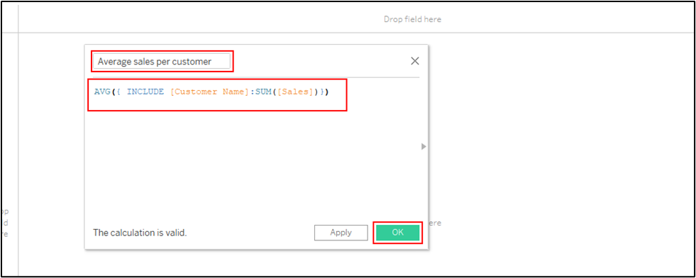

1. Create one more calculation to determine **Sales Goal** using the set and the previously created calculated field

Type the formula:

**IF MIN([States with 100+ Customers])= TRUE THEN SUM([Sales])*1.3**

**ELSE 100* [Average sales per customer]**

**END**

1. Create a calculated field to find emerging and developing states. Enter name as **Emerging or Developing State.** Enter the formula:

**IF COUNTD([Customer Name])>=100 THEN "Developing State" ELSE "Emerging State"**

**END**

1. To create a view from measures, drag **Sales Goal** onto **Columns**

1. From dimensions, drag **State** to **Rows**

1. From dimensions, drag **Customer Name** next to **State**

1. Select aggregation as **Count Distinct**

1. Right-click the **Customer Name** pill, and from the context menu, select **Discrete**

1. Drag the **Sales** measure to **Columns**

1. Open **Show Me** and select the **Bullet Chart**Chart, bar chart

   Description automatically generated
2. To bring **Sales Goal** to the column, right-click the **Sales axis** and select **Swap Reference Line Fields**

1. From measures, drag and drop the **Emerging or Developing** calculated field to **Color**

1. Rename the worksheet as **Developing and the Emerging States**A picture containing graphical user interface

   Description automatically generated
2. Keep the workbook open for the next exercise.

**Answers:**

Based on the view, these are the answers to the questions in the problem statement:

1. Which state has the lowest customer count, and what is the count?

Answer: **Wyoming,** and the count is **1**

1. How many states have a customer count of at least 100? Answer: **12**